2023 GivingTuesday Fundraiser Guide
Tuesday, November 28, 2023

Thank you for hosting a GivingTuesday fundraiser! Everything included here is just a suggestion. We fully appreciate that some families are very open about sharing their experience, and others are very selective about what they share. Please design your campaign to meet your family’s preferences. We are so grateful to you for hosting a fundraiser – no matter what it looks like!

Our recorded training (24 minutes) that includes a demonstration of launching a Facebook fundraiser may also be a helpful resource. Watch it here.

Examples of successful past ASXL fundraisers
Below are links to the campaigns of past successful fundraisers using the strategies described in this document. Check them out for inspiration!

- Stephanie’s 2022 GivingTuesday fundraiser
- Kelsey’s 2022 GivingTuesday fundraiser
- Laura’s 2022 holiday giving fundraiser
- Sarah’s Shashi-Pena Syndrome Awareness Day fundraiser

If you have any questions, please email Amanda Johnson at amanda@arrefoundation.org
Table of Contents
Option 1: Facebook fundraiser 2
Step-by-step guide 2
Suggested calendar for Facebook posts 3
Option 2: Personalized Qgiv fundraising page (with or without Facebook integration) 4
Step-by-step guide 4
Sharing your campaign 5
Suggested calendar for personal fundraising pages 5
Additional help documents and video: 6
Personalizing your campaign 6
Writing prompt 1: Your family’s story 6
Writing prompt 2: Living with unknowns 7
Inviting supporters 8
Tips for sharing your campaign 8
Sample invitation message (by email) 8
Sample follow-up message (by email) 8
Thanking your supporters 8
For donors who don’t wish to donate through Facebook or online 9
Additional text resources 9
Additional video and image resources 12

Option 1: Facebook fundraiser

Watch the full video tutorial here

Step-by-step guide

- Launch your campaign
Start the process of creating your campaign via this URL: www.facebook.com/fund/arrefoundation

- How much do you want to raise?
You can choose goal for your campaign. We recommend starting with $500 (you can increase it later if you need to)

- Select your currency

- When should your fundraiser end
December 5, 2023 (one week after GivingTuesday)

- What is the title of your fundraiser?
Whatever you would like! You can keep the default title (“[Your name]’s fundraiser for the ARRE Foundation”) or pick something else that you think will speak to your potential donors.

Some ideas using different syndromes and kids’ names:
- Finding answers for Bohring-Opitz Syndrome
- Isabelle’s GivingTuesday fundraiser
- Research for Gabi’s rare disorder

- Campaign description: “Why are you raising money?” prompt
Descriptive text will auto-populate when you launch your Facebook fundraiser (left column below). We recommend making changes to this text to customize it to your personal story. The text on the right can be copied/pasted into the “Why are you raising money?” prompt if you are comfortable sharing this information with your campaign supporters.

Facebook’s default text | Recommended custom text
Want to join me in supporting a good cause? I'm raising money for ARRE Foundation and your contribution will make an impact, whether you donate $5 or $500. Every little bit helps. Thank you for your support. I've included information about ARRE Foundation below.  The ARRE Foundation supports research and education for Bohring-Opitz, Shashi-Pena, and Bainbridge-Ropers Syndromes, extremely rare genetic disorders that most doctors have never heard of, let alone know how to treat.  Your gift will make a big impact in helping find answers through research. The ARRE Foundation is providing education to parents and caregivers about managing their loved ones’ many medical complications, bringing more researchers to the table to study these syndromes, and encouraging families to actively participate in research.  Thank you for your investment in answers for families.  Facebook takes care of the donation processing with no fees. | Want to join me in supporting a cause that’s really important to me and my family? I’m raising funds for GivingTuesday for the ARRE Foundation, the organization that supports research for the rare genetic disorder that impacts [insert loved one’s name] and our family every day.  [Insert loved one’s name] has [Bohring-Opitz/Shashi-Pena/Bainbridge-Ropers] Syndrome, an extremely rare genetic disorder that most doctors have never heard of, let alone know how to treat. The ARRE Foundation is supporting families like ours by providing education that helps parents and caregivers understand how to manage our loved ones’ many medical complications, bringing more researchers to the table to study these syndromes, and encouraging families to actively participate in research.  Your contribution in honor of [insert loved one’s name] will make a big impact in helping find answers through research. Your contribution supports the ARRE Foundation’s work to find more answers for families like ours. Thank you!

- Cover photo
The default picture for your campaign will be the ARRE Foundation’s cover page (a GivingTuesday themed picture). You can use this default OR request a custom header image from Amanda Johnson featuring your loved one’s picture.

To request a custom cover photo: Send your preferred photo and campaign name to amanda@arrefoundation.org to request a custom cover photo. (You can use the default image to start, and replace it later with a custom image.)

Examples of custom cover images:
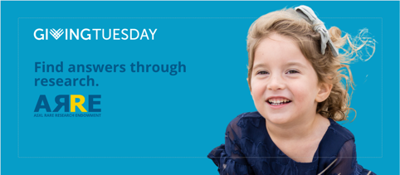
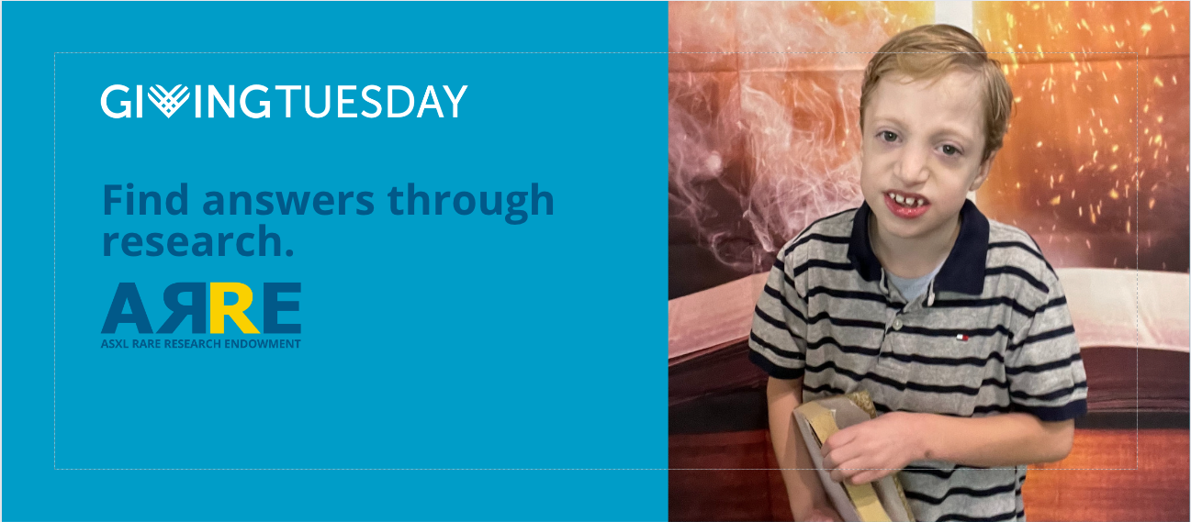

- Launch campaign
Select “Create” – and your campaign will now be live!

Suggested calendar for Facebook posts
November 21: Launch your campaign
November 22: Post the link to the video that describes your syndrome
November 24: Post a family picture and share a story about life with your loved one’s syndrome related to this picture. Is it a moment of joy? A challenging one? A hopeful one?
November 26: Post the “About the ARRE Foundation” video
November 28: Post the GivingTuesday graphic
November 29: Post the thank you graphic

A few things about Facebook fundraisers
- All fundraisers are posted publicly, even if your profile is set up to be private
- Facebook uses an algorithm to choose what to display on each person’s feed, so people in your network will not always see your posts in chronological order, and may not see them on the day you post them. This is why we encourage you to post ahead of GivingTuesday and not just on GivingTuesday.

Option 2: Personalized Qgiv fundraising page (with or without Facebook integration)

Watch the full video tutorial here

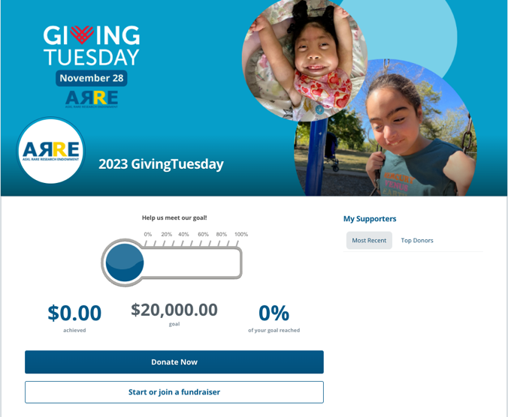
Step-by-step guide
- Go to the GivingTuesday campaign page
- Select “Start or join a fundraiser”
- Choose to start an individual fundraiser or start a team
  - Individual option: Great if you’re fundraising by yourself
  - Team option: Great for groups who are working toward the same goal together but each team member wants to have their own campaign pages (example: a mom, aunt, and teacher all working together toward the same campaign goal in honor of the same child)
- Set your campaign goal
  - Our suggested minimum goal is $500
- Complete the contact information fields; select Next
- Add an optional donation to start your campaign
- Select “Complete registration”
- Select “My fundraising dashboard” to start to customize your page
- Select “Complete my profile” to follow the set-up wizard to customize your campaign
  - Your profile picture
  - Your campaign page
  - Sending a campaign email
- Connect your campaign to Facebook (optional) by following the prompts (See the “Additional help documents and videos” below for a guide)

Orientation to key parts of the “My Fundraising Dashboard” page
- Share Event: allows you to send messages
- My Donations: allows you to:
  - See who has contributed to your campaign online
  - Manually enter any offline gifts you receive (i.e. a check)
  - Update your campaign goal
- Resources: includes documents, videos, and graphics provided by the ARRE Foundation to help you run your campaign
- Edit My Page: allows you to change what your campaign landing page looks like

Sharing your campaign
There are multiple ways to share your fundraising page:
- Copy the link to your campaign and share it with your network via email or text
- Use the Facebook integration option to publish your campaign to Facebook
  - All donations received via Facebook will count toward your campaign goal
- Use the built-in email templates to share your campaign with your contacts

Suggested calendar for personal fundraising pages
November 21: Finalize your campaign page and launch
      - Email/text: Share your campaign link with your network
      - Facebook: Post your campaign to Facebook (optional)

November 22: Facebook: Post the link to the video that describes your syndrome

November 24: Facebook: Post a family picture and share a story about life with your loved one’s syndrome related to this picture. Is it a moment of joy? A challenging one? A hopeful one?

November 26: Facebook: Post the “About the ARRE Foundation” video

November 28: Email/text: Reminder of your campaign
Facebook: Post the GivingTuesday graphic

November 29: Email/text: Send a thank you message to your contact list and note your campaign is open through December 6th
Facebook: Post the thank you graphic

Additional help documents and video:
- Video (7 minutes): Overview of the Participant Fundraising Center (how to manage your peer-to-peer fundraising page)
- Video (2 minutes): How to set up a Facebook Fundraiser on your peer-to-peer fundraising page
- Document (PDF): How to link a Facebook Fundraiser to your peer-to-peer fundraising page
- Video (1 minute): How to make a donation to a peer-to-peer fundraising page

Receiving offline gifts (by check):
If you receive any contributions by check, go to My Donations and enter the amount received to count it toward your fundraising goal. Please ensure the checks are made payable to ARRE Foundation and mail them to:
ARRE Foundation
PO Box 4662
Portland, ME 04112

Personalizing your campaign
Before you start inviting people to your campaign, we recommend making at least one post first to tell more of your story. You can do this as soon as you launch your campaign, or the next day.

Writing prompt 1: Your family’s story

If you’re open to sharing some insight into your family’s life with an ASXL syndrome, here are some suggested prompts to help you write your story:
- What is life like with Bohring-Opitz/Shashi-Pena/Bainbridge-Ropers Syndrome?
- What was your journey like to find your diagnosis?
- If you waited a long time to get your diagnosis, what was it like when you met other families who had the same diagnosis?
- What are the challenges that families who don’t have a loved one with an ASXL syndrome wouldn’t know about (therapies, specialists, unknowns)?
- What are your joys and victories? What’s something you’re really proud of your loved one for doing or accomplishing (big or small!)?
- What are your hopes that we can accomplish through research? What do you most want an answer to?

Example personal story that could be modified to fit your family:
On January 30, 2019, our life changed forever. After months of not being able to figure out why Lydia wasn’t meeting her developmental milestones and seeing specialist after specialist, we were finally referred for genetic testing. We learned that she has an extremely rare genetic disorder called Bainbridge-Ropers Syndrome caused by a random change to her ASXL3 gene.

The shock of a life-altering diagnosis was compounded when we learned there is no treatment for her syndrome. And then we learned that it’s barely mentioned in the medical literature. Her care team of specialists and therapists are wonderful, but we are making it up as we go along: there are no treatment guidelines for kids with Bainbridge-Ropers Syndrome. We have navigated intense feeding difficulties when she was an infant (vomiting for days), hundreds of hours of physical therapy to finally walk at 25 months, and learning to use a speech device to help her communicate. We are so proud of what she has accomplished on her own timeline but we do not know what lies ahead.

This GivingTuesday, we are raising funds for the ASXL Rare Research Endowment Foundation, a nonprofit patient advocacy organization started by parents like us who want more for our kids. The ARRE Foundation funds research projects and is building the network of doctors and scientists who can study disorders of the ASXL genes. They also host educational programs for families like us so we can learn more about how best to care for our kids.

Please make your gift today to the ARRE Foundation to support research into Lydia’s syndrome.

Additional text resources about the ARRE Foundation, our mission, and ASXL syndromes can be found below.

Writing prompt 2: Living with unknowns
Imagine getting a complicated diagnosis for your child, and then learning there’s no treatment for it. And then imagine learning that there are only a handful of research papers to guide your child’s many doctors as they figure out how to care for the person you love most.

[Optional: Add a brief story of 2-3 sentences about a challenge you’ve experienced due to a lack of knowledge about ASXL syndromes]

That’s the difficult reality for families like us, and hundreds of other families around the world. But with the ARRE Foundation there is hope for answers.

The ARRE Foundation is bringing together the doctors and researchers needed to build the body of medical knowledge that will guide the care of kids like [love one’s name] and help them live to their fullest potential.

Please invest in families like ours by making your donation today.

Inviting supporters

Tips for sharing your campaign
Share your campaign far and wide! Here are some tips for sharing your campaign:
- Use your campaign’s sharing tools to:
  - Invite friends and family to support your campaign
  - Share your campaign on your Facebook page
  - Share your campaign with permission on the Facebook page of other people you’re close with to widen your reach (your spouse, a grandparent, other close friends/family)
- Email the link to your campaign to colleagues, your child’s care team, teachers, or others who you may not be Facebook friends with

When you share your campaign, use messaging that follows these guidelines:
- Make a clear call to action in your message.
- Make it personal! Tell your story and why supporting research and education is important to you.
- Make it clear what a donor’s gift will support.

Sample invitation message (by email)

Dear [NAME]:

I'm excited to be participating in GivingTuesday, the international day of giving on November 28, to raise money for the ARRE Foundation. The ARRE Foundation is a patient advocacy organization with the mission of improving quality of life for individuals living with ASXL syndromes. These are complex, very rare genetic disorders that have impacted someone I care about. There are no known treatments for these challenging disorders, but the ARRE Foundation is trying to change that by funding research.

Will you help me meet my fundraising goal and support ASXL research? You can visit my page and make a donation here: [INCLUDE CAMPAIGN LINK]

Your gift will make a big impact in helping find answers through research. The ARRE Foundation is providing education to parents and caregivers about managing their loved ones’ many medical complications, bringing more researchers to the table to study these syndromes, and encouraging families to actively participate in research.

If you can think of others who might be interested in making a donation, please forward this email to them or share it on social media! The ARRE Foundation is a great organization and you’d be helping them (and me!) by spreading the word.

Thank you so much for helping me reach my goal, and for supporting ASXL research!

Sincerely,

[YOUR NAME]

Sample follow-up message (by email)

Dear [NAME]:

My fundraising campaign for GivingTuesday, the international day of giving on November 28, is fully underway to raise money for ASXL research through the ARRE Foundation! Could you contribute to my campaign to help me reach my fundraising goal?

The ARRE Foundation is a patient advocacy organization with the mission of improving quality of life for individuals living with ASXL syndromes. These are complex, very rare genetic disorders that have impacted someone I care about. There are no known treatments for these challenging disorders, but the ARRE Foundation is trying to change that by funding research.

Will you help me meet my fundraising goal and support ASXL research? You can visit my page and make a donation here: [INCLUDE CAMPAIGN LINK]

My campaign is open through December 5th. Thank you so much for considering a donation to the ARRE Foundation.

Sincerely,

[YOUR NAME]

See the resources below for additional suggestions.

Thanking your supporters
Please thank your donors personally!
- On Facebook: A post will appear on your fundraiser page every time someone makes a donation. We recommend thanking each donor individually by commenting under the post that shares their donation.
- On your fundraising page: Email your donor personally with your thanks

If this is overwhelming to do as donations are made over the week of your campaign, consider doing thank yous in batches (i.e. once per day).

Additional text resources
You can include any of these additional “blurbs” in your campaign. Please feel welcome to tailor them.

About the ARRE Foundation
The ASXL Rare Research Endowment (ARRE) Foundation is a family-led organization that supports research and education that improve the quality of life for families living with ASXL syndromes.

The ARRE Foundation is providing education to parents and caregivers about managing their loved ones’ many medical complications, bringing more researchers to the table to study these syndromes, and encouraging families to actively participate in research.

The problem we’re solving: why we need research
There are no treatments for the underlying genetic cause of ASXL syndromes. Most individuals require a high degree of subspecialty care to manage symptoms and complications.

Due to the limited research on ASXL syndromes, there are significant unknowns about how the ASXL genes work and what they do. Similarly, there are few evidence-based publications for medical professionals to reference in managing the care of someone with an ASXL syndrome.

A significant challenge of the ASXL community is that families often see specialists who do not have the knowledge or experience to properly manage their care due to the rarity and unknowns of their syndrome. In many cases, parents and caregivers become the experts in their child’s care and take on an outsized role in advocating for their child’s needs.

About ASXL syndromes
There are three ASXL syndromes that are typically caused by a random (de novo) genetic mutation on one of the three ASXL genes:
ASXL1/Bohring-Opitz Syndrome (BOS),
ASXL2/Shashi-Pena Syndrome (SPS), and
ASXL3/Bainbridge-Ropers Syndrome (BRS).

We believe there are approximately 500 people diagnosed in the world with these three syndromes, and many more living undiagnosed.

Each syndrome is unique but has overlapping common features on a wide spectrum of severity:
Developmental delay
Intellectual disability
Low muscle tone (hypotonia)
Gastrointestinal complications, including feeding difficulties and constipation
Delayed or absent speech
Orthopedic challenges
Behavioral and sensory challenges
Seizures

About Bohring-Opitz Syndrome (ASXL1)
Bohring-Opitz Syndrome is a rare neurodevelopmental disorder caused by a change (commonly called a mutation) in the ASXL1 gene. This change is typically random and not inherited from a parent. We believe there are 150-200 people diagnosed with Bohring-Opitz Syndrome in the world, with many more living undiagnosed.

There is significant variability in the severity of symptoms of people who have BOS and we don’t yet have a good understanding of why that is. Some of the most common characteristics include:

- Gross motor delay of varying severity
- Intellectual disability of varying severity
- Distinct features of the face and head, including a heart-shaped birthmark on the forehead, prominent eyes, and head shape anomalies
- “BOS posture” where the wrists are turned inward
- Feeding difficulties in infancy, including cyclic vomiting that may be extreme and lead to hospitalization
- Respiratory infections, particularly in infancy
- Seizures
- Obstructive sleep apnea

About Shashi-Pena Syndrome (ASXL2)
Shashi-Pena Syndrome is a rare neurodevelopmental disorder caused by a change (commonly called a mutation) in the ASXL2 gene. This change is typically random and not inherited from a parent. We believe there are 45-50 people diagnosed with Shashi-Pena Syndrome in the world, with many more living undiagnosed.

There is variability in the severity of symptoms of people who have SPS and we don’t yet have a good understanding of why that is. Some of the most common characteristics include:
- Distinct facial features (large head, wide-set eyes, low set ears, birthmarks)
- Low muscle tone (hypotonia)
- Developmental delay
- Difficulty controlling blood sugar
- Constipation
- Orthopedic complications
- Heart defects
- Behavioral and sensory challenges
- Seizures

About Bainbridge-Ropers Syndrome (ASXL3)
Bainbridge-Ropers Syndrome is a rare neurodevelopmental disorder caused by a change (commonly called a mutation) in the ASXL3gene. This change is typically random and not inherited from a parent. We believe there are 200-300 people diagnosed with Bainbride-Ropers Syndrome in the world, with many more living undiagnosed.

There is significant variability in the severity of symptoms of people who have BRS and we don’t yet have a good understanding of why that is. Some of the most common characteristics include:

- Intellectual disability of varying severity
- Developmental delay of varying severity, including speech delay or absent speech
- Behavioral concerns, including features of autism
- Feeding difficulties (particularly in infancy), including cyclic vomiting
- Low muscle tone (hypotonia)
- Seizures
- Palate and dental abnormalities

What your contribution supports

Example donation equivalents – ARRE Foundation programs and services
- $25 – 1 month of website service to bring educational resources to families
- $50 – 1 month of management of our email group for doctors and researchers
- $100 – Sending brochures for newly diagnosed families to 4 doctors offices
- $150 – Development of an educational webinar for families
- $250 – 1 night’s hotel at a genetics conference to raise awareness with doctors
- $1,000 – A travel grant for a young researcher to attend the ASXL Research Symposium

Example donation equivalents – quantifiable elements related to your child’s life
Please tailor these to be reflective of your family’s experience.

- $10 donation - $1 for every specialist [child’s name] has seen
- $30 donation - $1 for every month our family lived without a diagnosis
- $150 donation - $1 for every hour [child’s name] spends in therapies each year
- $500 donation - $1 for each person diagnosed in the world with an ASXL syndrome

Additional video and image resources
About the ARRE Foundation “Finding answers through research”
Link: https://youtu.be/8cIReUspaw4

“What is Bohring-Opitz Syndrome?”
Link: https://youtu.be/7ntCz0GuYXk

“What is Shashi-Pena Syndrome?”
Link: https://youtu.be/dAbXBVf-LC8

“The Faces of Shashi-Pena Syndrome”
Link: https://youtu.be/RFk5_UwIkyM

“What is Bainbridge-Ropers Syndrome?”
Link: https://youtu.be/C9znFp_COM0

A Day in the Life with Bainbridge-Ropers Syndrome
Link: https://youtu.be/bnpBYqtYx9U

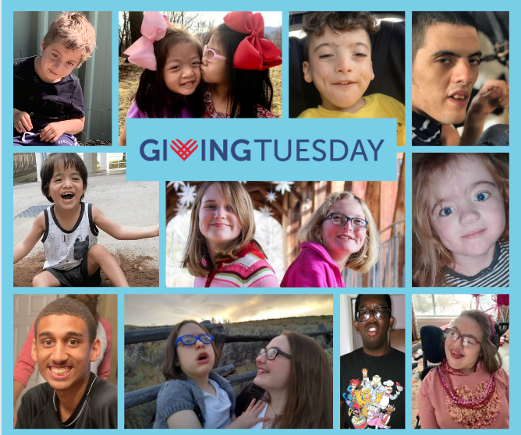
GivingTuesday day-of graphic
Download here

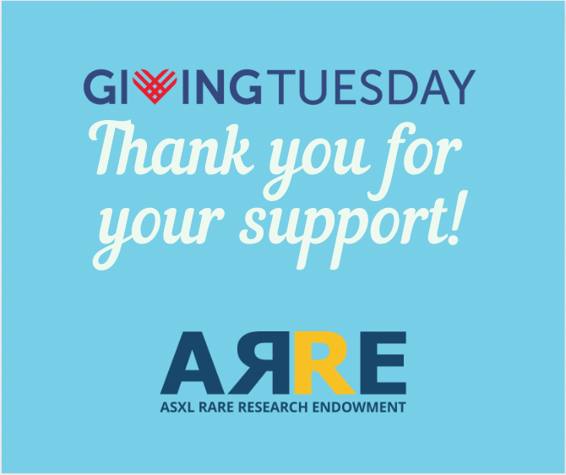
GivingTuesday thank you graphic
Download here

